1920’s Inventions Notes
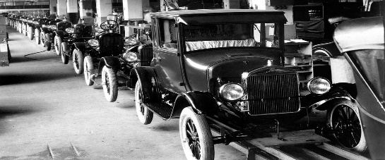 | a. Henry Ford’s use of the ___________________made  automobiles more __________________, through factory  _________________________.
B. Results of improved transportation:
1. _________________of transportation –related industries  - ___________ construction  - ___________  - ___________  - ____________________ | 2. __________________________  - ___________ people were needed to work in factories and transportation related industries.  3. ________________________________  -it was _________________ for people to travel from place to place.  4. Movement to ____________________  areas – (______________ of the cities
C. The ___________________  _____________invented the first  _____________________ at Kitty Hawk, North Carolina in 1903. | 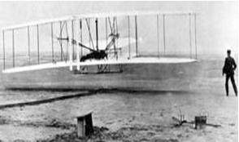

Definition of Electrification - the use of ___________________ to make things _____________.

- Ways electrification changed American life in the 1920’s

- ____________-______________ products (washing machines, electric stoves, water pumps)… allowed people to

_____________________________________________________________ .

- Electric ____________________… allowed people to

_____________________________________________________________ .

- __________________________ (e.g., radio)… allowed people to

_____________________________________________________________ .

Communication in the 1920’s

Change in communication | Picture
- ________________ availability of ________________  - _______________________________________ | 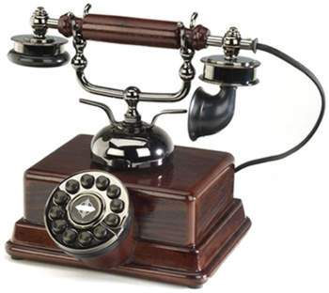
- Development of the ___________________  - ______________________________________ | 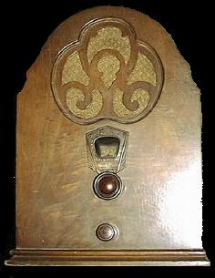
- Development of the ____________________ industry  - ______________________________________ | 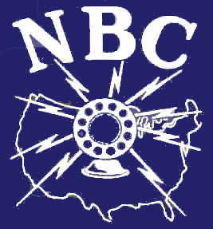
- Development of the ____________________  - Al Jolson is pictured on the right in the first talking movie, “The Jazz Singer.” | 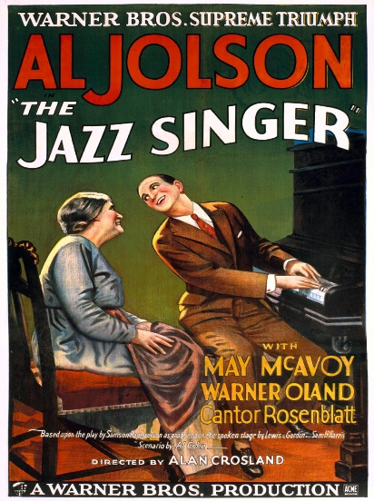

_____________________ extended progress into all areas of American_____________,

including neglected _________________ areas.

