Spanish American War
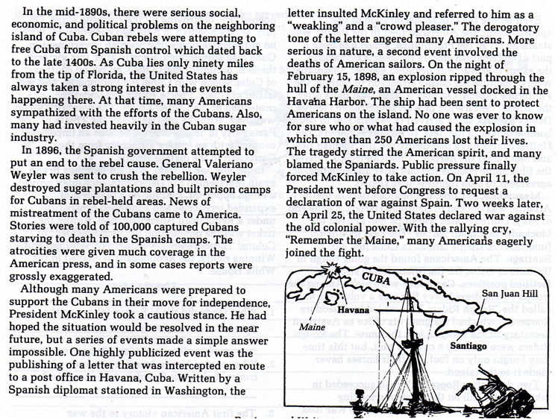

Answers First: The answers are given to you; so you have to create the questions. (Think jeopardy)
- Question: ________________________________________________________
Answer: 90 miles of the tip of Florida.

- Question: _______________________________________________________
Answer: Business Investments in Cuba and the exaggerated news reports.
- Question: ________________________________________________________
Answer: Letter about McKinley and the Bombing of the USS Maine.
- Question: ________________________________________________________
Answer: “Remember the Maine!!”
Answer the following questions normally using complete sentences.
- What were Cuban Rebels attempting to do?

- How did General Valeriano persecute the Cubans?

- What did McKinley take a cautious stance?

- Explain all the events that lead to the Spanish American war.

Terms to know:
• _____________________________- expansion of a nation's authority by conquering other non-contiguous territories or nations.

• _________________________________- news that is based on sensationalism (exaggeration).

