Great Migration Story Board

Directions: Place the paintings below into an order of your choice and add captions to create a story about the Great Migration.

Your story MUST include:
- All 6 pictures
- A beginning, middle, and end
- At least 2 push factors
- At least 2 pull factors
- A caption of at least one complete sentence below each picture.

This assignment is due by the end of class in the dropbox.

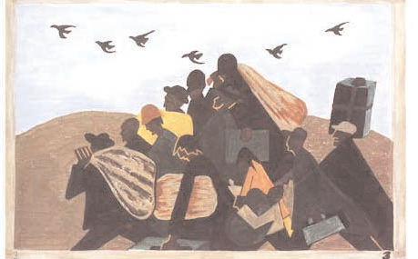

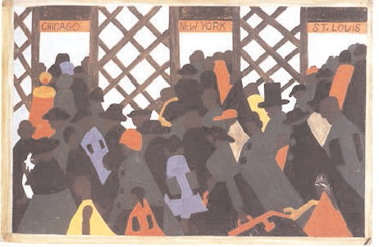
6
5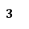
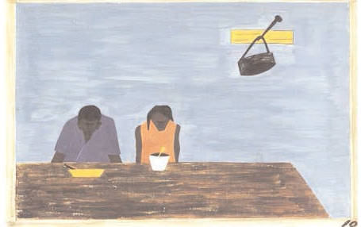

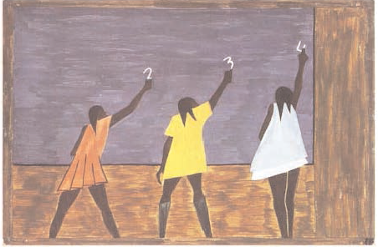

Picture

4
3
1
2

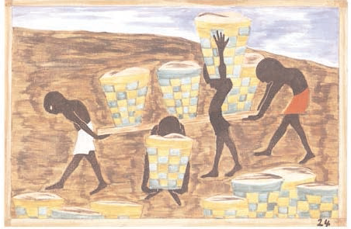

They decided that the best solution was to move to the North where there were better opportunities for their family.

The Jones family didn’t like that their children were receiving a poor education in the South.
