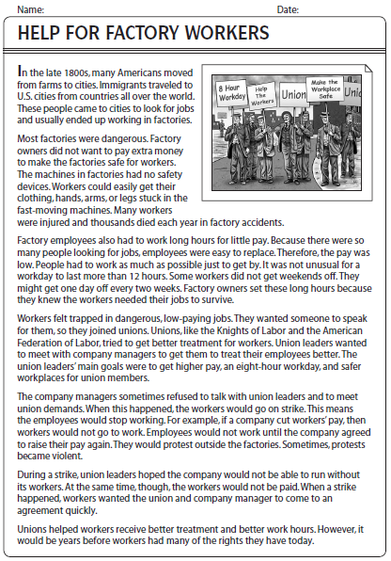
Name:___________________________________

1. What two things happened in the 1800’s?

2. Why were factories dangerous? What could happen to the workers?

3. Why were factory workers paid so low?

4. How much did workers work? Hours and days….

5. What are Unions?

6. What did Unions want from company managers?

7. What happened when company managers refused to give in on demands?

8. Describe what happens in a strike?

9. What did workers eventually get from Unions?

10. Do you know of any Unions in real life?

