- Population changes, growth of cities, and new inventions produced interaction and often conflict between different cultural groups.

- Population changes, growth of cities, and new inventions produced problems in urban areas.

Reasons for the increase in immigration
- Hope for better opportunities
- Desire for religious freedom
- Escape from oppressive (harsh, cruel, or unfair) governments
- Desire for adventure

Reasons why cities grew and developed
- Specialized industries
- Steel - Pittsburgh
- Meat packing - Chicago
- Immigration to America from other countries
- Movement of Americans from rural to urban areas for job opportunities

- Rapid industrialization and urbanization led to overcrowded immigrant neighborhoods and tenements.

Efforts to solve immigration problems
- Settlement houses: an institution in an inner-city area providing educational, recreational, and other social services to the community.
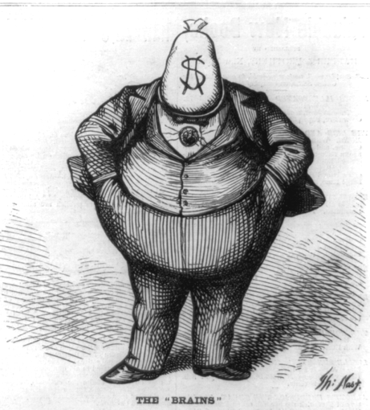
- Hull House founded by Jane Addams in Chicago
- Political machines: gained power by attending to the needs of new immigrants. Offered jobs or a place to live to immigrants in exchange for votes.
- Political Machine: organization, headed by a single boss or small group that commands enough votes to maintain political and administrative control of a city, county, or state.

Challenges Faced by Cities
- Tenements (poorly built, overcrowded housing where many immigrants lived) and ghettos (places of with high number of any minority)
- Political corruption (political machines used legal and illegal methods to ensure that their candidates won elections)

