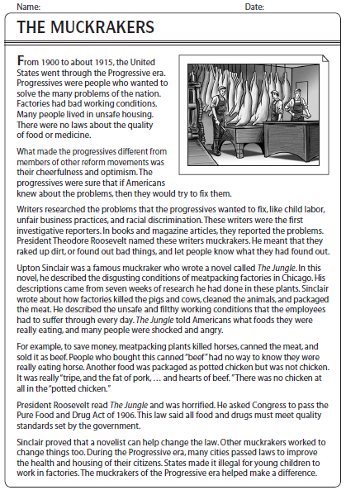
Name:_____________________________ Date: _______________
1. What was a progressive? What did they want?

2. What were the problems of the nation? (3)

3. What were the progressives sure of?

4. EXPLAIN how writers helped the progressives.

5. What did President Roosevelt call the Progressives? Why did he call them that?

6. Who was Upton Sinclair? What did his book do?

7. What was in “canned beef”?

8. What was in “potted chicken”?

9. What was Roosevelt’s reaction to the Jungle? What did he ask for?

10. How did “Muckrakers” change cities and states?

