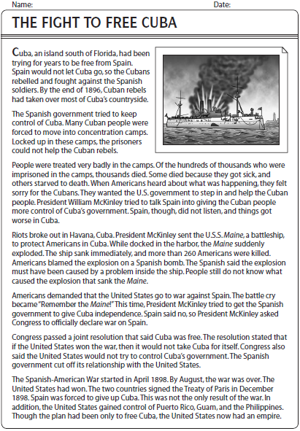
Name:_______________________________ Date:________________
1. Describe the situation in Cuba.

2. What happened to the Cuban people?

3. Describe the treatment of people in the camps

4. What did McKinley first try and do? Was he successful?

5. What happened in Havanna?

6. What happened to the USS Maine?

7. What was the battle Cry after the sinking of the Maine?

8. What did the Congressional resolution say about the future of Cuba?

9. How long did the war last?

10. What was the outcome of the Spanish American War?

