Name: __________________________ Date________
- What year was the Spanish American War? Who fought?

- 1. 2.

Reasons for the Spanish
American War.

3. 4.

- Results of the Spanish American war?
a.

b.

c.

- The Roosevelt __________________ was an addition to the ______________ Doctrine.

5.
Roosevelt Corollary

- 2.

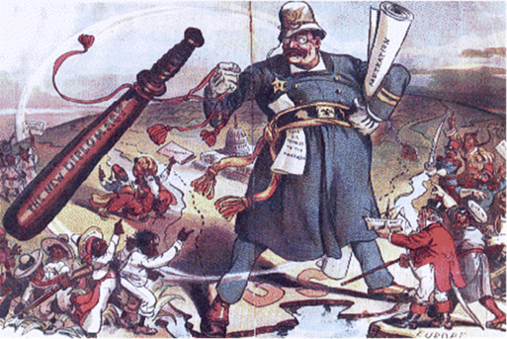

6. The cartoon shows Teddy ________________’s
_______ stick __________________.

Explain Roosevelt’s Policy:

7. What event was the catalyst that started WWI?

8. What was the first declaration of war that started WWI?

9. The Allied Forces:

10. The Central Powers:

11. Reasons the USA Joined
World War One

12. At the end of World War I, President _____________________ prepared a peace plan

known as the _________________________________ that called for the formation of the

____________________________, a ______________________________ organization.

13. The __________________________________ decided not to join the _______________________

because the United States _________________ failed to ratify the ___________________________.

