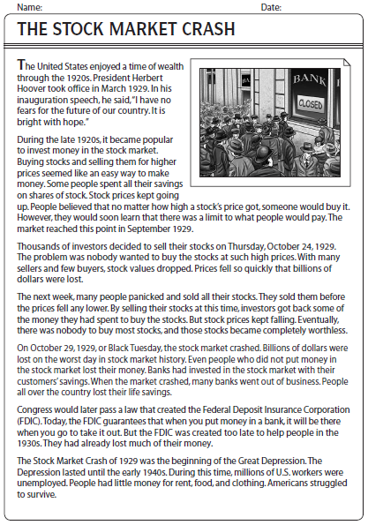
Name:______________________________________________ Date:_________________

1. When did the stock market reach its limit?

2. What was the problem with investors trying to sell their stocks?

3. What happened to the stocks that no one would buy?

4. What was the day called when the stock market crashed?

5. How did banks invest in the stock market?

6. What happened to many banks when the stock market crashed?

7. What does FDIC stand for?

8. What does the FDIC do?

9. What began the Great Depression?

10. How long did the depression last?

