Temperance/Suffrage Movement Fliers
Create TWO fliers advertising the temperance and women’s suffrage movements.
BE BRIEF- A flier is meant to be quick and informative.
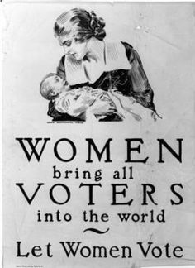
Make sure to include:

- Temperance-
- What temperance is
- Why women want temperance
- What amendments they support
- What problems did they feel alcohol caused

- Women’s Suffrage-
- What women’s suffrage is
- Why women want suffrage
- What amendment guarantees suffrage
- Famous suffragists who lead the movement

