The Roaring 20’s Webquest
Use the links provided to answer the following questions.

Movies in the 20’s: www.1920-30.com/movies

- Which format was used in the movies of the 1910’s- 1920’s?

- Name 2 film stars of this era.

- What was significant about the movie The Jazz Singer?

1920’s Culture:
- Name and draw inventions of the 1920’s:
http://www.buzzle.com/articles/inventions-of-the-1920s.html

- Define the following slang terms: www.huffenglish.com/gatsby/slang.html

- Cat’s meow----
- Flat Tire----
- Bee’s knees----
- Swanky----
- Torpedo----
- Hooter----
- Jalopy----

History of Jazz:
http://www.d.umn.edu/cla/faculty/tbacig/studproj/is3099/jazzcult/20sjazz/index.html and http://www.sheppardsoftware.com/usa_game/harlem_renaissance/harlem_renaissance_home.htm

6
. Write 5 Words
to describe a flapper:

http://history1900s.about.com/od/1920s/a/flappers.ht
m

FLAPPER

- Which city was Lois Armstrong from?

- What city is considered to be the birthplace of Jazz?

- Name 2 other Jazz musicians of the 1920’s.

- Name 2 locations in New York City that were popular Jazz clubs.

- What dance crazy was popular during the 1920’s.

Harlem Renaissance: Write a definition that includes at least 2 adjectives (circle them) about this era.

- What is each of these artists famous for?
- Langston Hughes—
- Jacob Lawrence—
- Duke Ellington—(1st website)
- Louis Armstrong—

Sports: http://library.thinkquest.org/C005846/categories/sports/sports.htm
- Name a leading athlete for each of the following sports below:
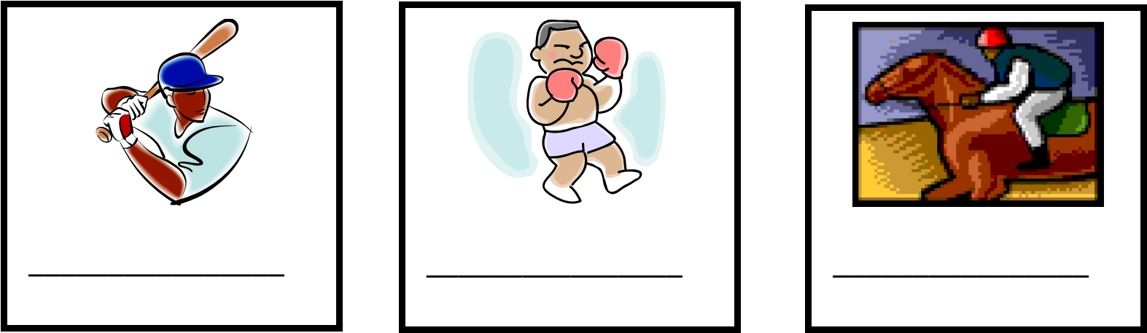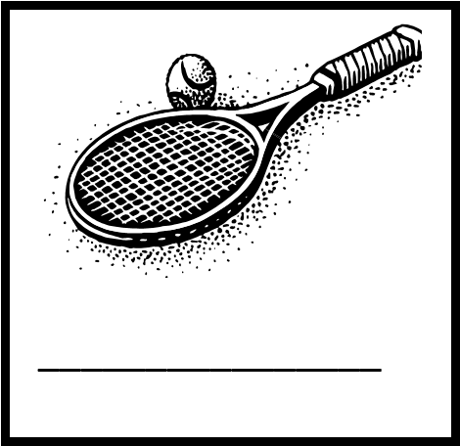

- Who were two famous aviators: http://acepilots.com/pioneers.html

Crime & Justice: Write one fact about each of these 1920’s
gangsters. http://www.trutv.com/library/crime/gangsters_outlaws/complete_list.html

- Al Capone—

- Carlo Gambino---

- John Joeseph Gotti--

- Which automobile would you pick?

